Use Case

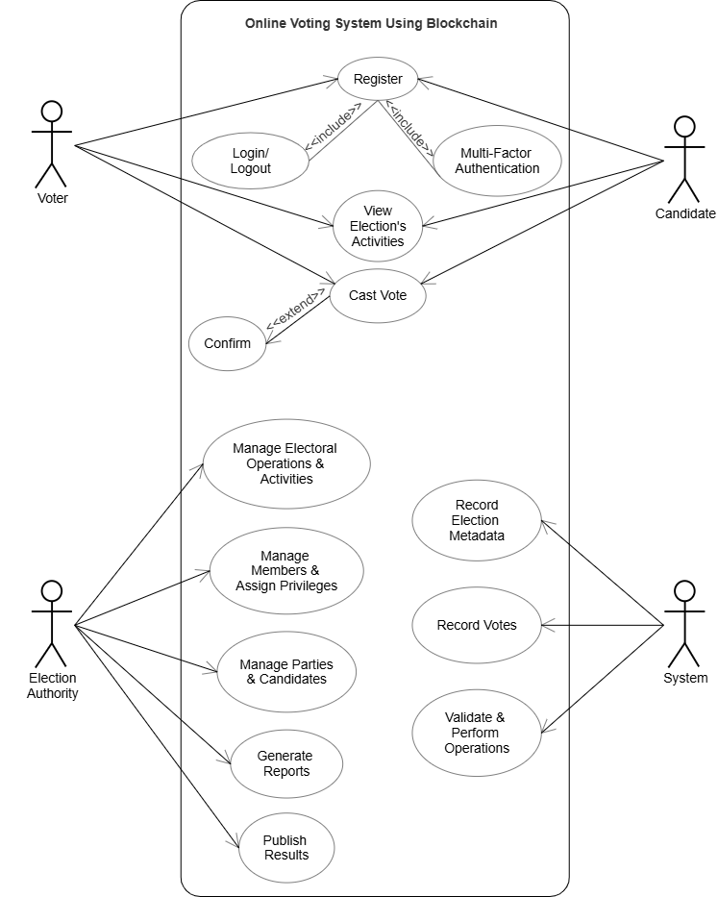

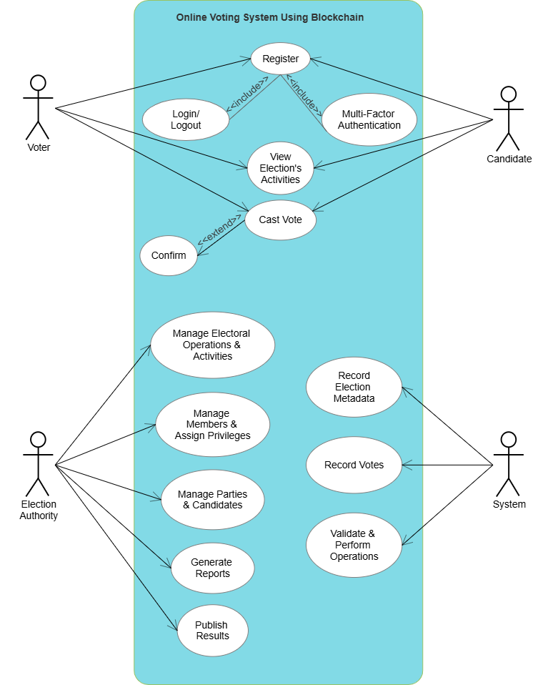

ISSUE in above diagram 🡪  
Party Head role missing,  
Candidate, party head works not perfectly shown there.  
Therefore nextone is correct use case diagram.



/

Party Head

This is correct diagram & its ss is kept below.  
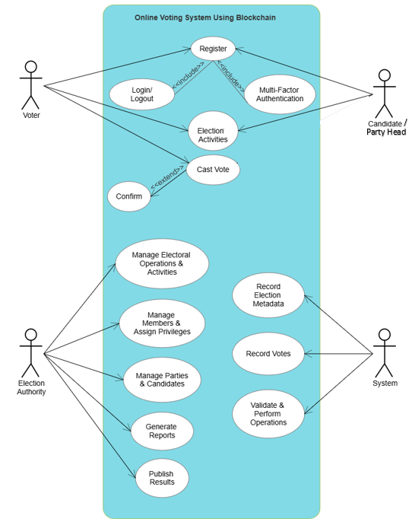

DFD Level 0

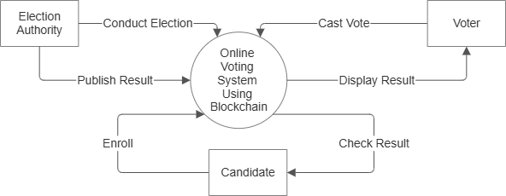

ISSUE in above diagram 🡪  
Party Head role missing,  
Below is proper ss of corrected one designed.

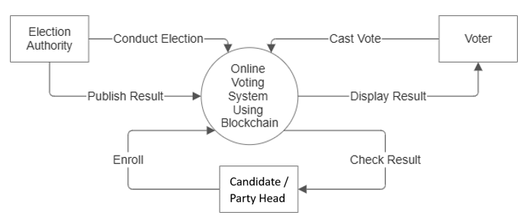

DFD Level 1

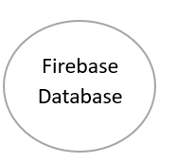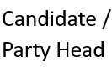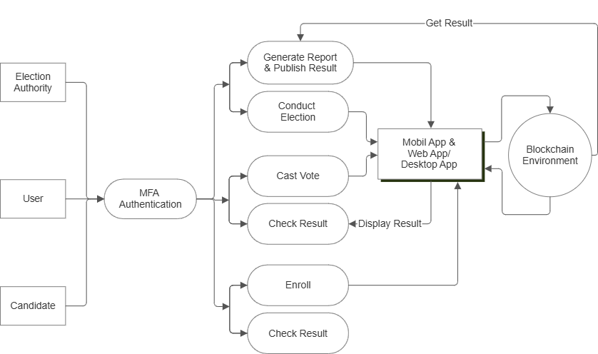

ISSUE in above diagram 🡪  
Party Head role missing + Firebase part is missing   
Below is proper ss of corrected one designed.

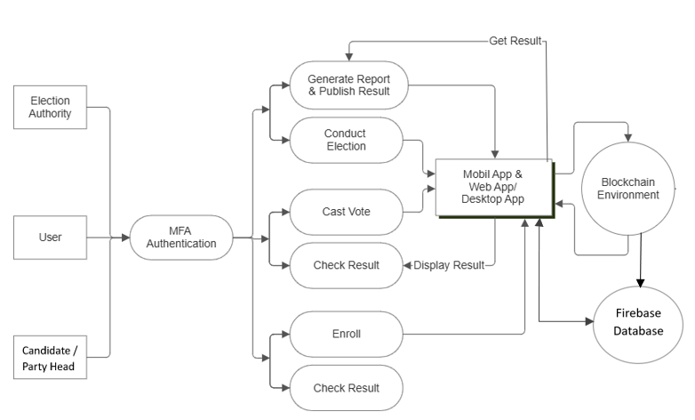

Sequence

